

Watershed Management Application

PEI Department of Communities, Land and Environment
PEI Employment Development Agency

2016

Application (MS Word Version)

(NOTE: guidelines for filling out the application can be found in the pdf version at the web address below)

For further information, contact:
Department of Communities, Land and Environment
31 Gordon Drive
Charlottetown, PEI C1A 6B8
www.gov.pe.ca/wmf

Tel: (902) 368-4686
Fax: (902) 368-5526

Watershed Management Fund Application
This is a combined application to be used by watershed groups to apply to the following funds at the same time:

Communities, Land and Environment: Watershed Management Fund
Greening Spaces Program
Employment Development Agency: Special Projects
Jobs for Youth

Please refer to the guidelines before completing the application.
This application can be downloaded as a PDF form at www.gov.pe.ca/wmf
Personal information on this form is collected under Clause 31(c) of the Freedom of Information and Protection of Privacy Act R.S.P.E.I. 1988, c. F-15.01 as it relates directly to and is necessary for evaluating applications for funding and will be used for making decisions regarding the acceptability of the proposed funding request and contacting the client. Information collected on this form may be shared with the Employment Development Agency for the purpose of technical review of the application If you have any questions about this collection of personal information, you may contact the Watershed & Subdivision Planning Section Manager, Department of Communities, Land and Environment, (902) 368-5054.
Submit Application to:  Watershed & Subdivision Planning Section  PEI Department of Communities, Land and Environment  31 Gordon Drive  Charlottetown, PE C1A 6B8 | For Office Use Only
Date Received: _________________________________

WMF Project Number: ___________________________
Part 1 – General Information
Organization Name:
Revenue Canada Business Number: | Date of Incorporation:____/____/____ or ___ N/A
Revenue Canada Business Number: | Workers Compensation Number:
Primary Contact: | Secondary Contact (1 contact must be a Board member):
Primary Contact Title: | Secondary Contact Title:
Primary Contact Phone/FAX: | Secondary Contact Phone/Fax:
Primary Contact E-mail: | Secondary Contact E-mail:
Organization Mailing Address:  ______________________________________________  ______________________________________________  ______________________________________________  ______________________________________________ | Public Listing Info:  (for website publishing and to use to refer public requests)  □ YES □ NO  Public Contact Person: ___________________________  Title: _____________________________  Phone: _________ Email: ________________________  Address:_______________________________________  ______________________________________________  Website: ______________________________________

Part 2 – Project Information
2016 Project Title:
PROJECT LOCATION/WATERSHEDS MANAGED
(indicate on attached map of PEI the area your group works in or attach a map that clearly shows the watersheds your groups works in):

MEMBERSHIP STATUS
Approximately how many current members (private and corporate) does your watershed group have? ______

WATERSHED PLANNING

Does your organization have a completed community-based watershed plan? □ YES □ NO □ IN PROGRESS

If yes, when was it completed and for which watershed(s):

If in progress, explain the stage of completion and when it is expected to be completed:

If no, does your organization plan to initiate a watershed planning process? Please explain.

If applicable, what portion of the geographic area covered by your organization does the watershed plan apply to? If less than 100%, what are your organization’s plans for the rest of the areas?

How does your group inform the group’s members and general public about the plan/planning process?

PREVIOUS PROJECT RESULTS
Please provide a list of work completed last year (April 1- current).

Did your group complete all of the activities listed in last year’s application/contract? □ YES □ NO □ NA
If not, what was not completed and why?

Long-term Project and/or Organizational Goals:

2016 Project Summary
2016 PROJECT GOALS

Project Activity | Anticipated Results
Please outline plans for future maintenance of the proposed work:

PARTNERSHIPS – Describe/list any working partnerships you have or will have with other organizations (e.g. other watershed groups) or whether your group has increased the area it works in.

Part 3 – Greening Spaces Program Information (optional)
Project Information required by the Greening Spaces Program
Why do you want to do the tree and shrub planting component of the project?

Do you have a letter of permission from the landowner where the trees and shrubs are to be planted? Please attach.

How many and which species of trees and shrubs do you propose to plant?

When do you plan to begin your project (fall or spring)?

Who will prepare the site, plant the trees, and maintain the site with regular watering, weeding, mulching, pruning, and general cleanup?

Outline your plans for communications, recognition and promotion of your GSP project.

Attach a photograph of the planting site or sketch the proposed planting site in this box.

Part 4 – EDA (optional)
Important notice – EDA now requires that all groups who apply to the Jobs for Youth or Special Projects Programs be incorporated under Part II of the Companies Act. Groups must have a current annual return filed with the Director of Corporations, as required by Subsection 91.(3) of the Companies Act.
Project Information required for Special Projects Program and Jobs for Youth Program
Requested skill set and employee type, other information (weeks requested, etc.) will be located in the Financial Information Form

Preferred Start Date for Each Proposed Employee (dd/mm/yyyy)

EDA Summary:
SPP # Supervisors requested: ___ Total Weeks: ____
SPP # Labourers requested: ___ Total Weeks: ____
JFY # Students requested: ___ Total Weeks: ____

Part 5 – Financial Information
Budget Summary by Expenditure Category
Expenditure Category |  |  | Total Cost ($)
 | # Workers | # Weeks | Cash |  |  |  |  | In-kind
 | # Workers | # Weeks | WMF | SPP | JFY | Other Funders  GSP
Supervisor
Labourers

Volunteers
MERC (Mandatory Employer Related Costs)
Watershed Planning Expenses
Equipment/Rental
Materials/Supplies
Travel
Office/Administration
Insurance
Professional Services
Other (Specify)
Subtotals |  |  | $ | $ | $ | $ | $
Total Project Value |  |  | $
WMF - Watershed Management Fund, Department of Communities, Land and Environment
SPP - Special Projects Program, PEI Employment Development Agency: Labourers, $10.92/hr (includes 4% vacation pay) @ 40 hrs per week, plus MERC.
Supervisors, $11.53/hr (includes 4% vacation pay) @ 40 hrs per week, plus MERC.
JFY - Jobs for Youth Program, PEI Employment Development Agency: All Students, $11.18/hr (includes 4% vacation pay) @ 40 hrs per week, no MERC provided.
GSP - Greening Spaces Program, Department of Communities, Land and Environment

Funding Partners/Contributors
Please list funding partners included in “Other Funders” above | Cash  ($) | In-kind  ($)
Authorizing Signature
Signature: Title:
Printed Name: Date:
2009-1.2

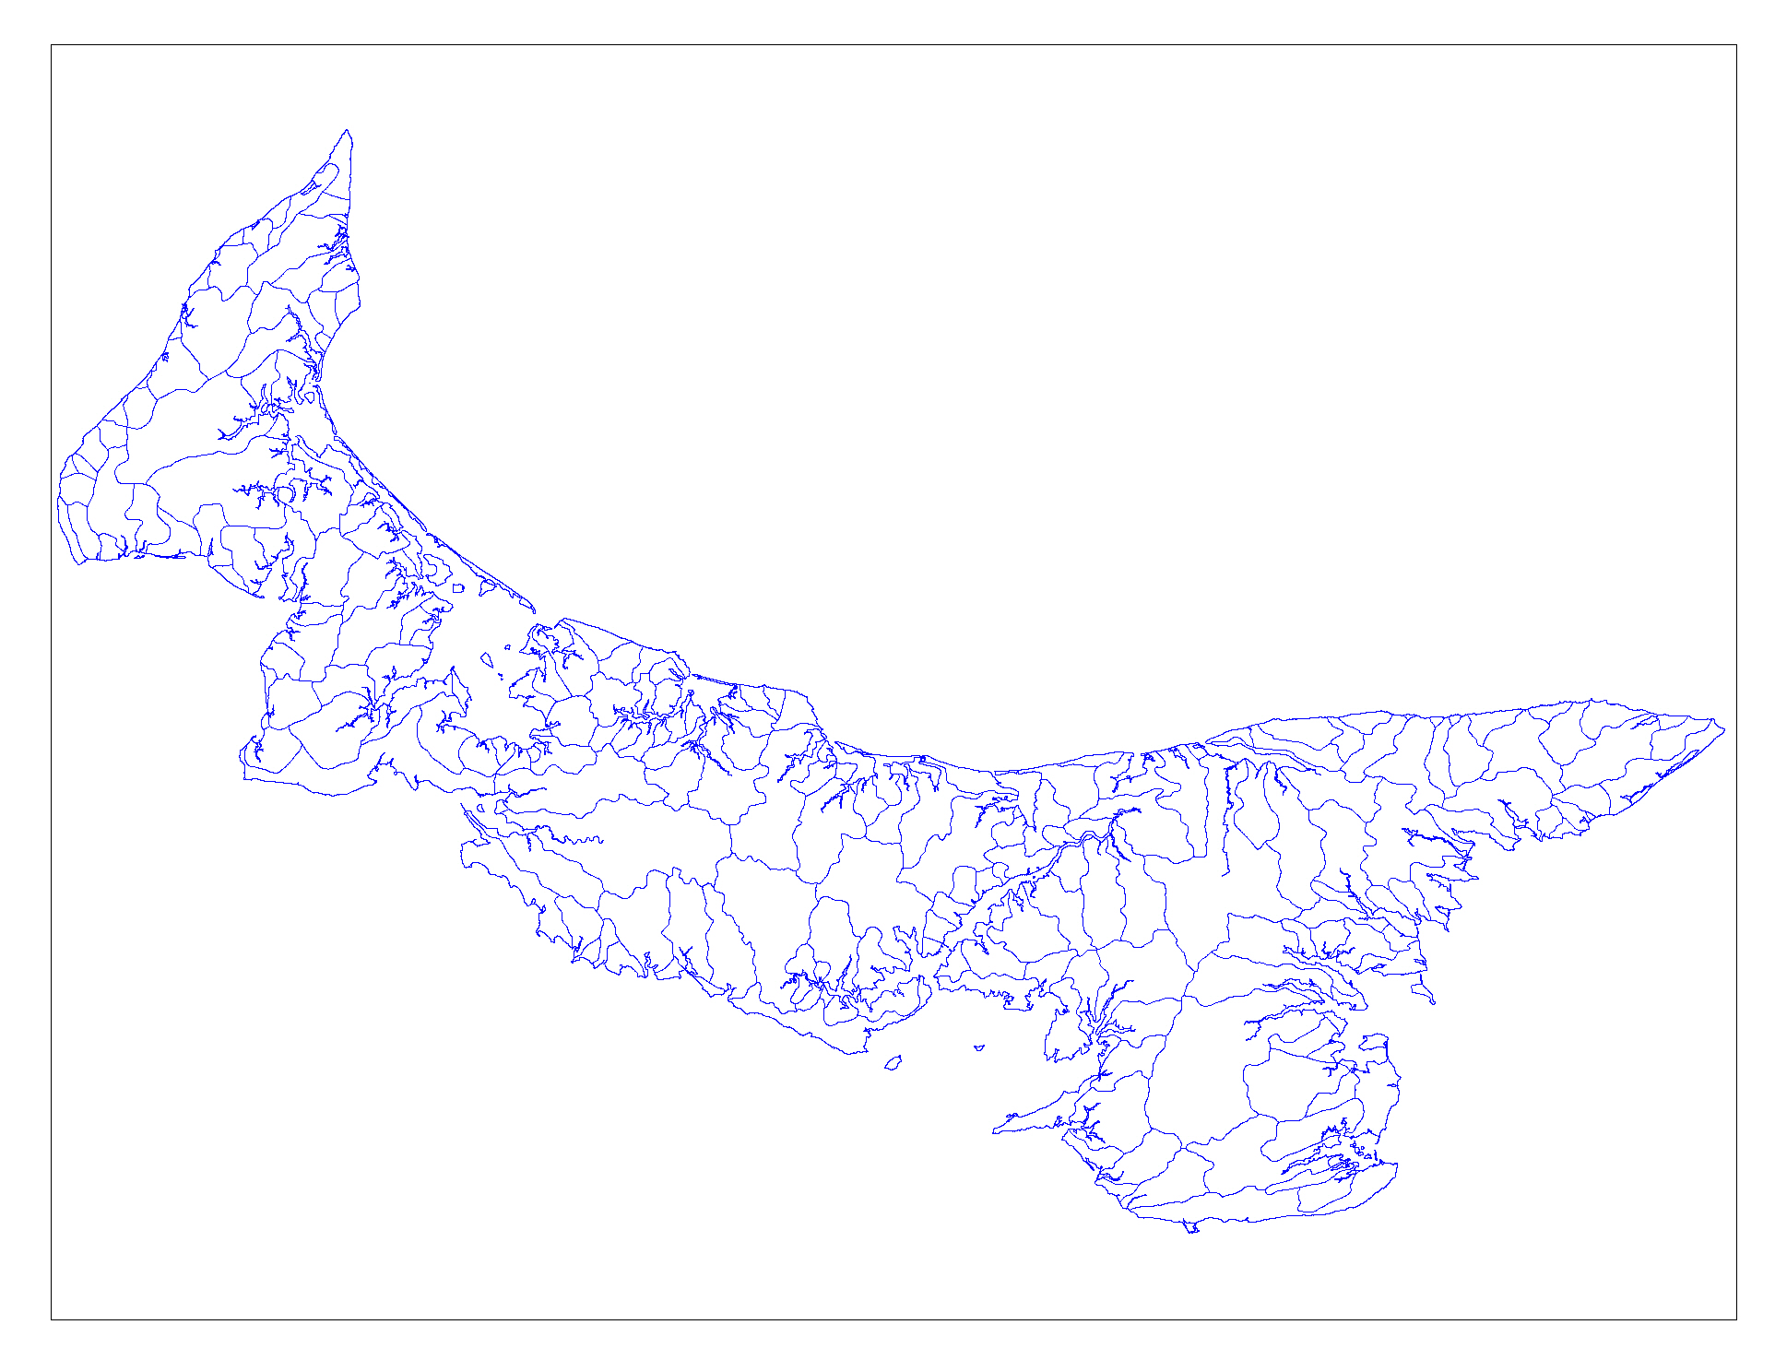

It is important that you have the proper landowner permission for each proposed activity before any work is started.

